FREEDOM OF INFORMATION REQUEST

FREEDOM OF INFORMATION REQUEST 2021/24418

Dear Sir/Madam

Thank you for your recent request under the Freedom of Information Act 2000.

Section 1 of the Freedom of Information Act 2000 (FOIA) places two duties on public authorities. Unless exemptions apply, the first duty at, Section 1(1) (a), is to confirm or deny whether the information specified in a request is held. The second duty at, Section1 (1) (b), is to disclose information that has been confirmed as being held.

The information that you are seeking is in relation to the following:

REQUEST

I am completing research on the roads policing unit and area support unit, I am requesting the detection rates from 2010-2015 and 2015 to 2020 for road related offences

Clarification

Please could I have the following from 2010-2015 and then 2015-2020

Drivers Licences
Insurance
Speeding
Drink Drive
Drug Drive
Fatal collisions
Number of S165’s issued
Number of S59’s issued

Also if you able please can I have a summary to the total number of Fixed Penalty notices and TORs have been issued for the same periods.

RESPONSE

Offences | 2010-2015 | 2015-2020
Drivers license | 7 | 720
Insurance | 7 | 3080
Speeding | 3 | 724
S165 | This is an insurance offence, see above figures.

The figures for 2010-2015 are low due to Pentip (the national system for recording traffic offences) automatically weeds data after a certain amount of time.

Drink driving

2019
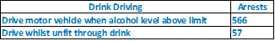
2020
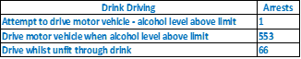

Drug driving

2019
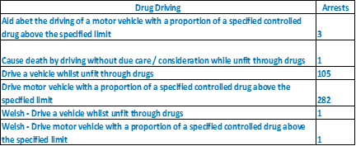

2020
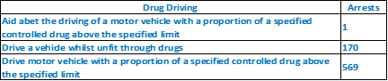

Please see below fatal collisions, between 2015-2020. The request for detection rates is still not specific enough as fatal collisions are generally classified and wouldn’t necessarily be detected.

2015 – 7
2016 – 17
2017 -17
2018 – 25
2019 – 19
2020 – 18

The data 2010-2015 is unavailable at this time.

Freedom of Information Act is a public disclosure regime, not a private regime. Any information disclosed under the Act is thereafter deemed to be in the public domain, and therefore freely available to the public and will be published on the Gwent Police website.

If you are not satisfied, you have the right to request an internal review into the response that you have received, or, to complain about our handling of your request.

Thank you for your interest in Gwent Police.

