FREEDOM OF INFORMATION REQUEST

FREEDOM OF INFORMATION REQUEST 2022/25402

Dear Requester,

Thank you for your recent request under the Freedom of Information Act 2000.

Section 1 of the Freedom of Information Act 2000 (FOIA) places two duties on public authorities. Unless exemptions apply, the first duty at, Section 1(1) (a), is to confirm or deny whether the information specified in a request is held. The second duty at, Section1 (1) (b), is to disclose information that has been confirmed as being held.

The information that you are seeking is in relation to the following:

REQUEST

1. Between 1st January 2015 and 31st July 2022, the total number of drones reported as
stolen within your force area and their corresponding dates.
2. Between 1st January 2015 and 31st July 2022 of those reported, please specify the
make and model of each drone (if recorded).
3. Between 1st January 2015 and 31st July 2022 of those reported, please briefly
breakdown and classify the type of theft, such as Theft from Motor Vehicle (TFMV),
Burglary Domestic, Burglary Commercial, Robbery etc for each of the occurrences.
4. Between 1st January 2015 and 31st July 2022 of those reported, please detail the cost
of the stolen item(s).
5. Between 1st January 2015 and 31st July 2022 of those reported, how many have been
recovered and how many have led to a conviction?
6. Between 1st January 2015 and 31st July 2022 of those reported, how many have
identifying features recorded, such as a serial number?

As an example, a typical data return could look like the following (please use a separate line
for each occurrence):
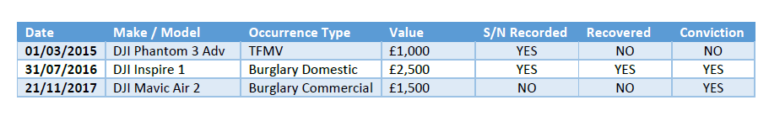
We have tried to keep the confines of the information request easy to research within a
crime recording system, and ensure that the information we are requesting, in relation to
thefts of drones, is in a reasonably retrievable format.

RESPONSE

Data only available from 2017 onwards:

Please note, we do not have access to conviction data and this can be obtained through the courts

Freedom of Information Act is a public disclosure regime, not a private regime. Any information disclosed under the Act is thereafter deemed to be in the public domain, and therefore freely available to the public and will be published on the Gwent Police website.

If you are not satisfied, you have the right to request an internal review into the response that you have received, or, to complain about our handling of your request.

Thank you for your interest in Gwent Police.

