FREEDOM OF INFORMATION REQUEST

FREEDOM OF INFORMATION REQUEST 2022 25546

Dear Requester,

Thank you for your recent request under the Freedom of Information Act 2000.

Section 1 of the Freedom of Information Act 2000 (FOIA) places two duties on public authorities. Unless exemptions apply, the first duty at, Section 1(1) (a), is to confirm or deny whether the information specified in a request is held. The second duty at, Section1 (1) (b), is to disclose information that has been confirmed as being held.

The information that you are seeking is in relation to the following:

REQUEST

Please provide the following information for the year 2021-2:
- A comprehensive list of employee job titles which feature any of the following phrases: equality, diversity, inclusion, wellbeing, carbon, energy, net zero, climate, change maker, race, BAME, LGBTQ+, sustainability, art, awareness, involvement, culture, solidarity, intersectionality, or green.
- The total number of employees with each job title.
- A total cost for the listed roles, including salary and employer pension contributions. There is no need to provide individually identifiable data.

RESPONSE

Please see the table below.

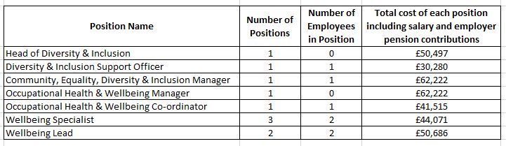

Freedom of Information Act is a public disclosure regime, not a private regime. Any information disclosed under the Act is thereafter deemed to be in the public domain, and therefore freely available to the public and will be published on the Gwent Police website.

If you are not satisfied, you have the right to request an internal review into the response that you have received, or, to complain about our handling of your request.

Thank you for your interest in Gwent Police.

