FREEDOM OF INFORMATION REQUEST

FREEDOM OF INFORMATION REQUEST 2022/ 25693

Dear Requester,

Thank you for your recent request under the Freedom of Information Act 2000.

Section 1 of the Freedom of Information Act 2000 (FOIA) places two duties on public authorities. Unless exemptions apply, the first duty at, Section 1(1) (a), is to confirm or deny whether the information specified in a request is held. The second duty at, Section1 (1) (b), is to disclose information that has been confirmed as being held.

The information that you are seeking is in relation to the following:

REQUEST

This is an information request relating to spending on communications, public relations, digital and other similar activities.

Please provide information for the 2020-21 and 2021-22 financial years on the cost of the communications team at the force, including
- The total remuneration bill, including salaries, pensions, bonuses for the communications team
- A list of staff working in the communications team for each of the financial years, including the job title, the pay band and what their FTE is (I am not seeking information on any personal details)

RESPONSE

Please provide information for the 2020-21 and 2021-22 financial years on the cost of the communications team at the force, including
- The total remuneration bill, including salaries, pensions, bonuses for the communications team
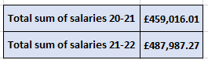
- A list of staff working in the communications team for each of the financial years, including the job title, the pay band and what their FTE is (I am not seeking information on any personal details)
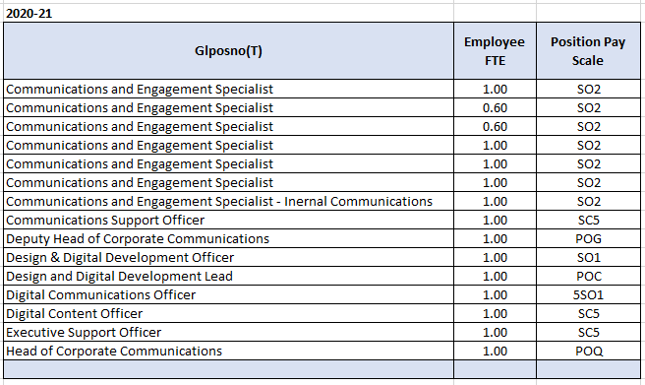

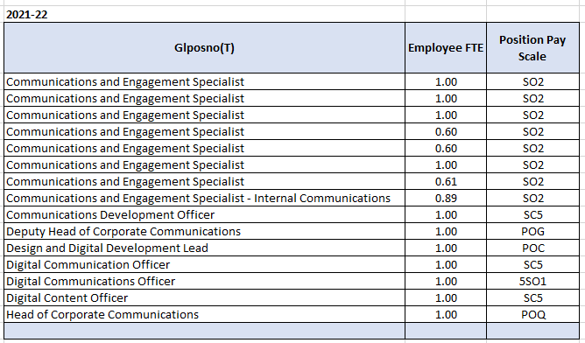

Freedom of Information Act is a public disclosure regime, not a private regime. Any information disclosed under the Act is thereafter deemed to be in the public domain, and therefore freely available to the public and will be published on the Gwent Police website.

If you are not satisfied, you have the right to request an internal review into the response that you have received, or, to complain about our handling of your request.

Thank you for your interest in Gwent Police.

