FREEDOM OF INFORMATION REQUEST

FREEDOM OF INFORMATION REQUEST 2022/25771

Dear Requester,

Thank you for your recent request under the Freedom of Information Act 2000.

Section 1 of the Freedom of Information Act 2000 (FOIA) places two duties on public authorities. Unless exemptions apply, the first duty at, Section 1(1) (a), is to confirm or deny whether the information specified in a request is held. The second duty at, Section1 (1) (b), is to disclose information that has been confirmed as being held.

The information that you are seeking is in relation to the following:

REQUEST

I'm writing to you to request information under the Freedom of Information Act. Please may you provide me with details on diversity statistics for your constabulary, broken down as per the below:

Police/Detective Constables and PCSOs
Total number of staff
- Ethnicity
- Nationality
- Gender (Male, female, transgender, non-binary, prefer not to say, other)
- Sexual orientation
- Age
Senior roles i.e. Sergeant upwards
Total number of staff
- Ethnicity
- Nationality
- Gender (Male, female, transgender, non-binary, prefer not to say, other)
- Sexual orientation
- Age
Total (all staff within your force)
Total number of staff
- Ethnicity
- Nationality
- Gender (Male, female, transgender, non-binary, prefer not to say, other)
- Sexual orientation
- Age

RESPONSE

We do not record nationality. Although citizenship is recorded, we do not have any reports that will provide this information.

Unfortunately, we cannot answer this part of the request as it will exceed the 18-hour time limit to complete a request. We currently have around 3500 staff and officers. In order to retrieve the data, each record would need to be reviewed. It would take approximately 30 seconds to review each individual record, which would equate to 29 hours of research. Therefore, a Section 12 Excess Cost exemption has been applied.

Section 12 – Excess Cost

The exemption applicable to the information you have requested for this question can be found at Section 12(1) of the Act and this refusal notice is issued under Section 17.

Section 12(1) “does not oblige a public authority to comply with a request for information if the authority estimates that the cost of complying with the request would exceed the appropriate limit.”

In the case of a police force, the appropriate limit is set at £450, which is calculated at £25 per hour (i.e. 18 hours). Gwent Police would have to conduct a manual search to find and extract the information for this question. This would take more than 18 hours of staff time therefore we are unable to answer this question and the exemption is engaged.

Police/Detective Constables and PCSOs
Total number of staff
- Ethnicity
- Nationality
- Gender (Male, female, transgender, non-binary, prefer not to say, other)
- Sexual orientation
- Age
**All below data is at 20/01/2023.
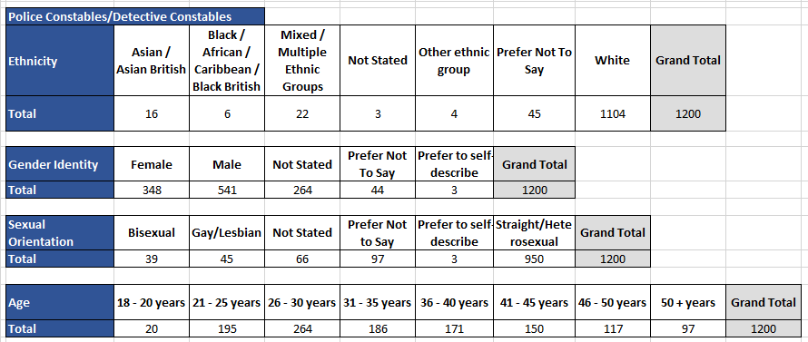
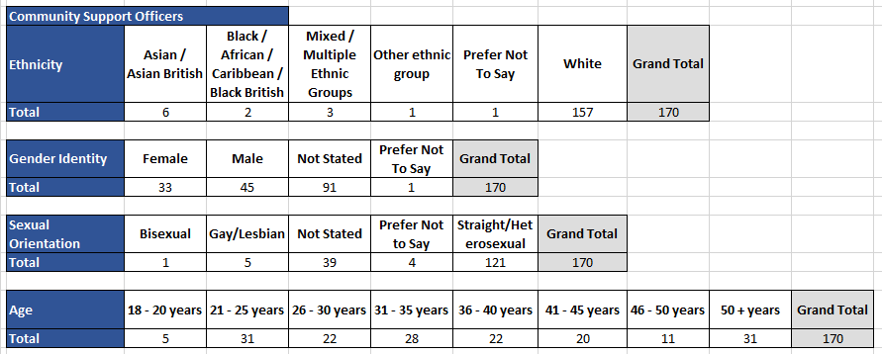
Senior roles i.e. Sergeant upwards
Total number of staff
- Ethnicity
- Nationality
- Gender (Male, female, transgender, non-binary, prefer not to say, other)
- Sexual orientation
- Age
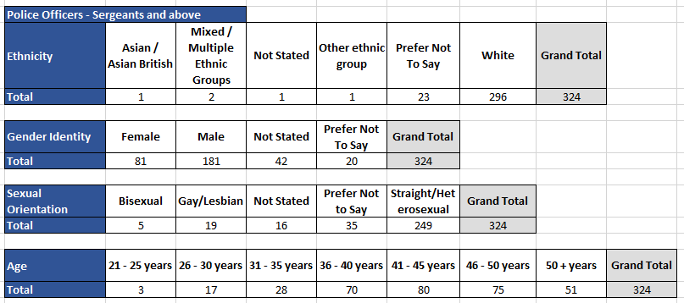

Total (all staff within your force)
Total number of staff
- Ethnicity
- Nationality
- Gender (Male, female, transgender, non-binary, prefer not to say, other)
- Sexual orientation
- Age
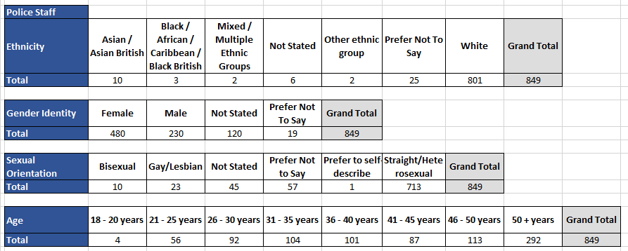

Freedom of Information Act is a public disclosure regime, not a private regime. Any information disclosed under the Act is thereafter deemed to be in the public domain, and therefore freely available to the public and will be published on the Gwent Police website.

If, upon receiving a response to a freedom of information request, you are unhappy with the outcome, you may request an internal review. This should be made within 40 working days of the initial response.

Please note, any written reply from an applicant expressing dissatisfaction with an authority’s response to a request for any information will be treated as a complaint and will automatically lead to an internal review.

Thank you for your interest in Gwent Police.

