FREEDOM OF INFORMATION REQUEST

FREEDOM OF INFORMATION REQUEST 2023/ 26038

Dear Requester,

Thank you for your recent request under the Freedom of Information Act 2000.

Section 1 of the Freedom of Information Act 2000 (FOIA) places two duties on public authorities. Unless exemptions apply, the first duty at, Section 1(1) (a), is to confirm or deny whether the information specified in a request is held. The second duty at, Section1 (1) (b), is to disclose information that has been confirmed as being held.

The information that you are seeking is in relation to the following:

REQUEST

As part of a wider project, I politely request the total number of police employees, separated by officers and staff, that died as a result of suicide whilst in paid employment within your force for the following years:

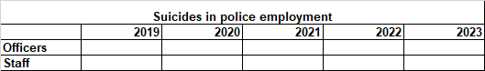

RESPONSE

We can confirm that there have been no suicides.

Freedom of Information Act is a public disclosure regime, not a private regime. Any information disclosed under the Act is thereafter deemed to be in the public domain, and therefore freely available to the public and will be published on the Gwent Police website.

If, upon receiving a response to a freedom of information request, you are unhappy with the outcome, you may request an internal review. This should be made within 40 working days of the initial response.

Please note, any written reply from an applicant expressing dissatisfaction with an authority’s response to a request for any information will be treated as a complaint and will automatically lead to an internal review.

Thank you for your interest in Gwent Police.

